**Design Outline**

The aim of our project is to build a website which serves as a platform for Purdue students from the same course to interact with each other. Our project will use the client-server model to set up a website that users could view the data about the course and interconnect with other users. In order to achieve this objective, we will connect the users to the website and store their account information and the information about each course on a MySQL database. The server serves as a mediator between the website and the database.

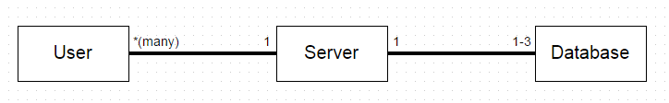

1. Website
   1. The website will be the place where the users can interact with other users in public (such as Q&A forum) as well as send personal message to other users.
   2. The website will display the course information for each course, and will display the information of each user as it applies to the courses they are taking. What each user allows other users to see of their profile is determined by the preferences in their account management.
   3. The user could also request for the setup of a course page if it doesn’t exist.
2. Server
   1. The server will serve as a middleman between the website and the database, whenever a request for database information is made.
   2. The server is also responsible for storing the code for displaying web pages and evaluating requests from users and acting accordingly.
3. Database
   1. We will create three databases for three different kinds of information.
   2. The first database is used to store information about the each user such as email, name, username, list of courses linked to, etc.
   3. The second database is used to store any information about the course such as the CRN, course info, students linked to the course, the identity of the professor, etc.
   4. The third database could be used to store any other information such as archives of forums, Q&As, or anything else needed.

**Overview of website**

We will have many users who are the clients and they are connected to the server by registering at the website, which will create an account for them. Then the server stores all the user information into our first database. Users could also request information from the website and the server will fetch any appropriate information from the database and display the information to the users.

**Overview of the database**

We are going to create 3 instances of databases using MySQL. Each of these databases will have different uses such as User information, Course information, and Forum archives. The reasons for doing so are to make it easier to keep track of the information and manage the security of the database. Using a database is preferable for security as accessing the information needs to be done through MySQL instead of just finding the plaintext file on the server.